To create a Word Count for each record in a column in Power Bi:
It is important to do this in Power Query because these functions are written in ‘M’ and that’s why you will not see them if you use the New Column tool in Power Bi Desktop
- Select Home Transform Data to open Power Query
- In Power Query first clean up your entries to avoid counting empty lines, tabs etcetera
  - Select the column to apply the word count to
  - Select the Transform Tab Text Column group Format Clean
  - Select the Transform Tab Text Column group Format Trim
- Select the Add Column Tab Custom Column
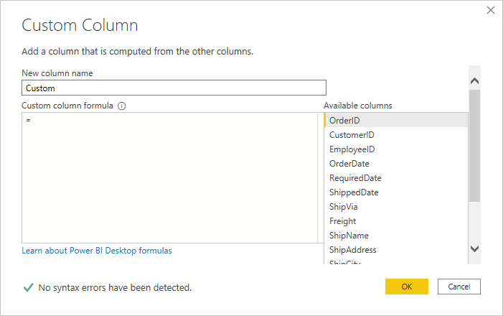
- Change the New Column Name to a Name of your choice
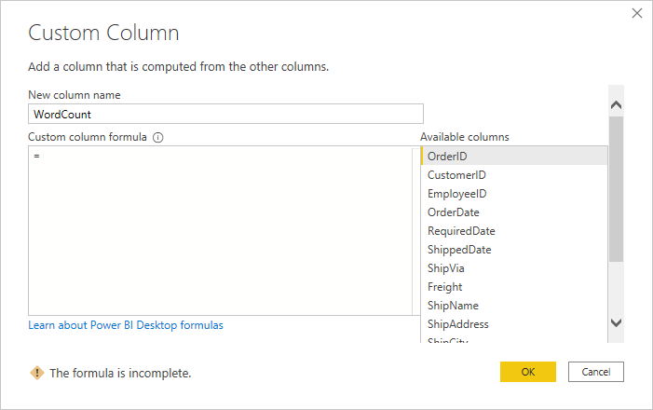
- Click after the ‘=’ under Custom column formula and start typing ‘SPLIT and you will see a series of split functions.
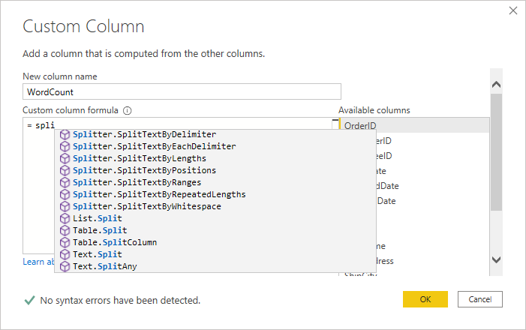
- Select Text.Split (this will split the entry in each row by a delimiter, in this case a space.
- Add an opening bracket and notice in the screenshot below that the arguments required for this function are a text item, which is the column you want to count the words in. I selected ShipName. The second argument is the delimiter separating the words in the column. I used a space (“ “)
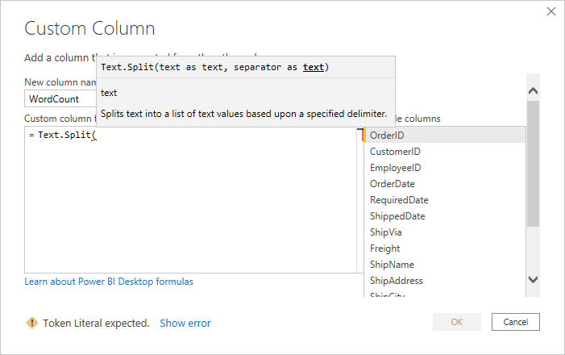
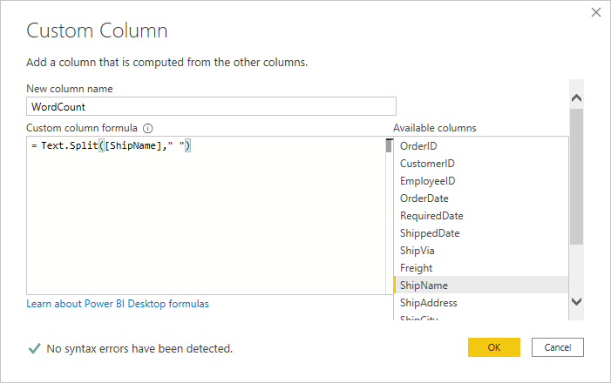
- We are now nesting this function inside a list.count function.
- Cut the function from the dialog box so it is on your clipboard. We are pasting it later
- Click after the ‘=’ under Custom column formula and start typing ‘COUNT’ and you will see a series of Count functions
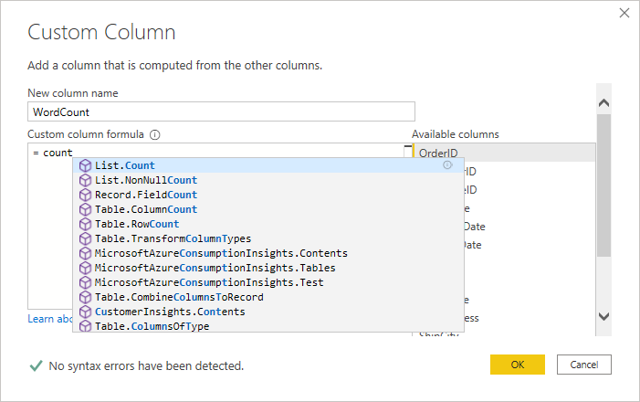
- Choose List.Count and then add an opening bracket to see the arguments.
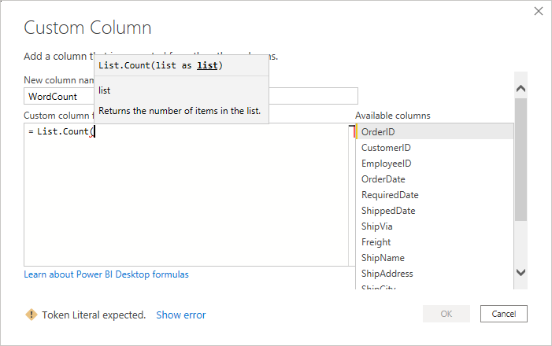
- Paste the split function that is on your clipboard
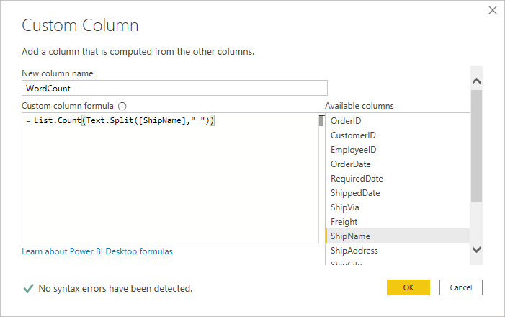
- Click OK
- Job Done

